**Topic 1A: Explain Cable Types and Connectors:**

Peripheral devices typically perform the input, output, or external storage functions.

Under the expansion card slot (not in use), we can see the rectangular metal strips. These metal strips are called **Blanking Plate.** It ensures proper air flow inside the components. If it is not covered with the blanking plates, it can disrupt the proper air flow in the PC that can cause overheating and increase the amount of dust in the system.

That Blanking Plate looks like this:

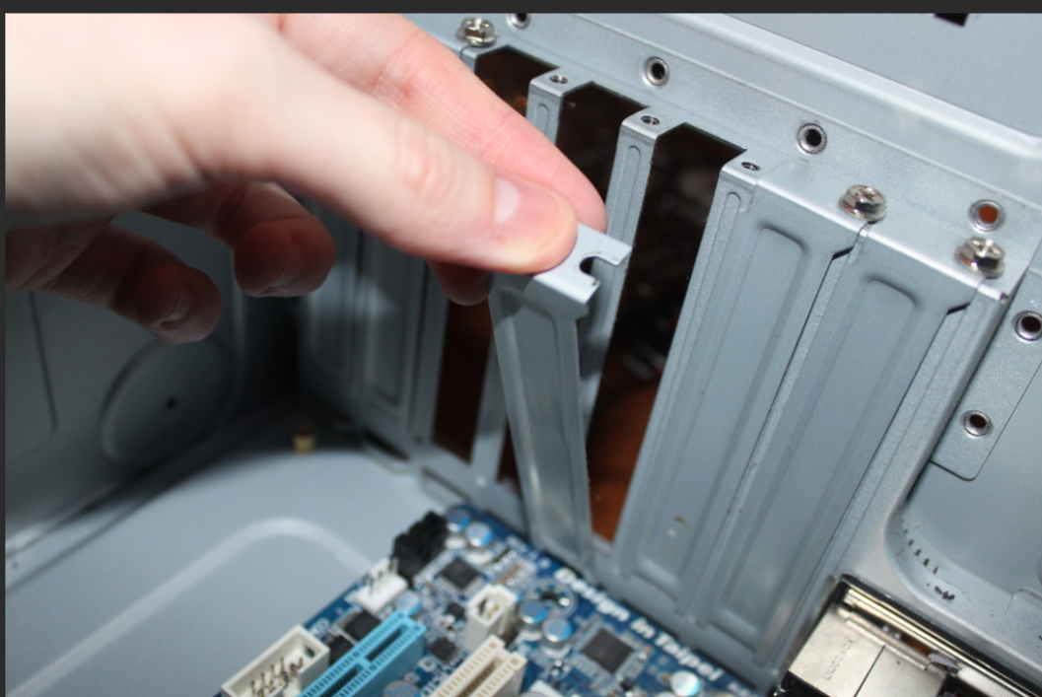

**Peripheral Devices:**

An input/output (I/O) port allows a device to be connected to the PC via a **peripheral cable.**

A peripheral cable means that wire which we connect between two components like USB cable, like the one we use in the **iPhone** charger. It has two connectors, one for charger head and one for mobile head. So, in any peripheral cable there are two connectors. In PC, there are different external hardware ports which allows us to connect a particular type of bus interface (**hardware**). A bus allows data transfer between to and from devices.

Most connectors and ports have an asymmetric design called **keying** to prevent them from being inserted the right way around or are reversible.

Remember, USB 3.0 port is blue color and USB 2.0 port is black in color.

**Binary Data Storage and Transfer Units:**

When comparing Bus Interfaces, it is important to use appropriate units. As computer understands everything in 1s and 0s, we compare the bus interfaces in the form of Bits (b) or Bytes (B).

**1000 Kilobits (Kbps or Kb/s) and 1 Kilobytes (KBps or KB/s)**

**UNIVERSAL SERIAL BUS CABLES**

The USB is the standard means for connecting most of the peripheral devices to the computer. USB peripheral devices are divided into classes such as human interface (keyboards and mice), mass storage (disk drives), printer, audio device, and so on.

Each USB port is managed by **the host controller** inside the computer. The host controller acts as a traffic manager that organizes how data is sent and received between the computer and the connected USB devices. In theory, **one host controller can manage up to 127 devices**. However, connecting too many devices at once can slow things down (just like too many cars on a highway). Because of these limitations, most computer motherboards include **multiple USB controllers** to handle the load better. For example, your PC might have 3 or 4 USB controllers, each managing a few ports.

For example,

Imagine you're at an office desk:

* Your **USB mouse and keyboard** are connected to one USB controller.
* Your **USB printer** and **phone charger** are connected to another controller. This division prevents your computer from slowing down even if you use multiple devices at once.

**USB Standards:**

Each new version of USB improves things like data speed (how fast data is transferred) and adds better features or new connector designs. **USB 2.0** offers speeds of **480 Mbps**, but all devices connected to the same bus (or "road") share this speed. **USB 2.0 is half-duplex:** This means devices can either **send** data or **receive** data at one time, not both. **USB 3.x is full duplex:** This allows devices to send and receive data **simultaneously**, making it faster and more efficient. It is important to remember these table things:

USB 3.0 has two sub-controllers inside which is for Super Speed USB like USB 3.0 or higher and another for lower speed USBs like 2.0.

**USB Type 2.0 and 3.0 main points:**

You can see the difference between different types of USB ports. Memorize it. And one more addition thing is that:

You can use **USB 2.0 Type A** connector to **USB 3.0 Type A port**, but the speed is limited to the max capacity of **2.0**. But you cannot **use USB 2.0 Type B** connector to **USB 3.0 Type B** port and **vice-versa**.

And we can see USB 3.1 also defines the **USB-C** Connector types. USB-C can use the same type of connector at both ends, or you can obtain USB-C to USB Type A or Type B converter cables.

**Cable Length:**

Max cable length for low speed devices is 3 meters, while for full speed and high speed devices is 5 meters. Super speed capable cables also recommended is 3 meters.

**Power**:

Bus can also supply power to the connected device. Most **USB Type A** and **Type C** ports can be used to charge the

battery in a connected device. As we can see these in phone chargers oftenly.

**HDMI AND DISPLAYPORT VIDEO CABLES:**

Any type of **Video Cables** bandwidth or transfer speed are determined two form factors:

* Resolution of the Image: **1920x1200 for HD** video and **3840x2160** for typical **4K**.
* Speed at which image is redrawn measured in **Hz** or **fps**. Fps is used to describe the video source whereas the hertz is the refresh rate of the display device or video interface. The refresh rate should match the frame rate or be evenly divisible by it. For example, if the frame rate is 60fps and the refresh rate is 120Hz, then the video should play smoothly.

Computer displays are typically of the liquid crystal display (LCD) thin film transistor (TFT) type. The color is determined through RGB values. The LCD panel is illuminated by the LED array or backlight. But in LED display types, each pixel has its own light source. That’s why LED displays are thin comparing to LCD displays because it does not require back light.

**High-Definition Multimedia Interface:**

Widely used video interface todays. It supports both **audio** and **video** plus **remote control** and **digital content protection (HDCP).**

HDMI cable is rated as Standard (Category 1) and High Speed (Category 2). High speed supports greater length and is required for v1.4 features such as 4K and refresh rates over 60Hz. HDMI versions **2.0** and **2.1** specify Premium High Speed (**up to 18 Gbps)** and Ultra High Speed (**up to 48 Gbps)** cable ratings.

**Display Port:**

**DisplayPort** is a way to connect your computer (or another device) to a monitor, TV, or projector to send **video and audio signals**. Unlike **HDMI**, it doesn't require manufacturers to pay royalties, so it's **cost-effective**. It supports features like **4K video resolution**, **audio**, and **content protection** (so copyright videos can’t be copied). There are two main types of DisplayPort connectors:

* **Full-size DP++**
* **MiniDP (or mDP)**: A smaller version for compact devices like laptops.

These connectors are designed with a shape that prevents you from plugging them in the wrong way.

It transfers data using **lanes** and it can use upto **4 lanes.** Each lane has 2.7 Gbps per lane but the latest version 2.0 can go up to **20Gbps** per lane.

1. The important feature of this over HDMI is **Daisy-Chaining** from which you can connect multiple monitors to a single **DisplayPort** on your computer.
   * For example:
     + One cable goes from your computer to Monitor 1.
     + Another cable goes from Monitor 1 to Monitor 2.
     + Another cable goes from Monitor 2 to Monitor 3.
   * With HDMI, you would need a separate HDMI port on your computer for each monitor.

You can see HDMI has bend both of the sides, but this Display Port Interface has bend one side.

**THUNDERBOLT AND LIGHTNING CABLES:**

It is the generally considered as USB-C. It can also be used as a display interface like DisplayPort or HDMI and like USB as we can see in phone chargers. **Thunderbolt version 1 and 2** uses the same physical interface as **MiniDP** and compatible with **DisplayPort** as well. But it can be distinguished by the **lightning bolt/flash icon**. **Version 2** supports 20Gbps. It supports daisy-chaining as well.

Thunderbolt version 3 changes the physical interface to use the same port, connector, and cabling as USB-C. **Thunderbolt 3** is a super-fast technology for transferring data, video, and power using the **USB-C port**. It can handle data speeds of up to **40 Gbps**, which is incredibly fast—ideal for things like connecting external hard drives, 4K monitors, or gaming setups. If you plug a **regular USB device** (like a flash drive or mouse) into a Thunderbolt 3 port, it will work normally. However, if you try to plug a **Thunderbolt device** (like a super-fast external SSD) into a standard USB-C port **that is not Thunderbolt-enabled**, it won’t work.

Thunderbolt 3 can transfer up to **40 Gbps** using a high-quality, short cable (up to 0.5 meters or 1.6 feet). If the cable is longer or of lower quality, the speed may drop.

**Lightning Interface:**

Used in previous iPhone chargers. Unlike USB or other connectors, **only Apple devices** have Lightning ports. The **Lightning connector** can be plugged in **either way**, making it easy to use (no wrong direction). If you want to connect your iPhone or iPad to something like a computer, you’ll need a **Lightning-to-USB-A** or **Lightning-to-USB-C** cable.

**SATA HARD DRIVE CABLES**

**SATA** is a technology used to connect **internal storage drives** (like hard drives or SSDs) inside a desktop PC or laptop. It’s the standard way your computer communicates with its storage devices to store and retrieve data.

**Cables and Connectors:**

* **SATA Data Cable (7-pin):** This thin cable connects the storage device (e.g., a hard drive) to the computer's motherboard for data transfer.
* **SATA Power Cable (15-pin):** This separate cable connects the storage device to the computer's power supply to provide power.

**Important:** The **7-pin data cable** only transfers data—it doesn’t supply power. That’s why a separate **15-pin power cable** is necessary.

Each **SATA port** on the motherboard can only connect to **one device**. So, for multiple drives, you’ll need multiple SATA ports. SATA cables can be up to **1 meter (39 inches)** long, which is enough for connecting internal drives in most PCs.

**Speeds (SATA Revisions):**

The SATA standard has evolved to support faster data transfer speeds:

* + - **SATA Revision 1**: Up to **150 MBps** (megabytes per second)
    - **SATA Revision 2**: Up to **300 MBps**
    - **SATA Revision 3**: Up to **600 MBps** (common in modern PCs)

To convert MBps to Mbps, just multiply by 8 because 1 Byte = 8 bits.

**Molex Power Connector:**

**Molex connectors** are old-style connectors used to provide **power** to internal components inside a computer, such as older hard drives, optical drives, or fans. They are **4-pin connectors** made of white or clear plastic. Molex connectors are used to supply **power only** (not data) to devices inside a PC. Each wire in the Molex connector has a specific purpose, and the colors indicate the type of electrical current:

* **Red:** Supplies **5 volts**.
* **Yellow:** Supplies **12 volts**.
* **Black:** Acts as the **ground** (return path for electricity).

**External SATA (eSATA):**

**eSATA (External SATA)** is a version of the SATA standard designed specifically to connect **external storage drives** (like external hard drives or SSDs) to a computer. It uses a specialized cable and port for faster and more reliable data transfer compared to USB. **Internal SATA cables** **cannot** be used for external connections because they are not designed for that purpose. eSATA supports cables up to **2 meters (78 inches)**, which is longer than typical internal SATA cables. With an **eSATAp cable**, you can connect devices using either USB or eSATA, and the port provides power to the device as well.

Suppose you have an **external hard drive** that supports **eSATA**:

* You would use a **special eSATA cable** to connect the drive to your computer’s **eSATA port**.
* If your external drive also has USB connectivity, you could use a USB cable instead, but the data transfer might be slower than eSATA.

**Some Questions related to Cables and Connectors Parts:**

**1. Should the technician obtain and install a blanking plate after removing an adapter card from a PC?**  
Yes, the technician should obtain and install a blanking plate. Blanking plates prevent dust buildup, maintain proper airflow for cooling, and help maintain electromagnetic interference (EMI) shielding within the PC case.

1. **What type of USB connector is shown in the exhibit?**

This is USB 2.0 Type B Micro cable connector.

**3. What is the nominal data rate of a USB port supporting Gen 3.2 2x1?**  
The nominal data rate of **USB 3.2 Gen 2x1** is **10 Gbps (gigabits per second)**. Note that:

* "Gen 2x1" means 2nd generation with a single lane.
* For "Gen 2x2," the nominal data rate would be **20 Gbps**.

**4. True or false? USB-C ports and connectors are compatible with Apple Lightning connectors and ports.**  
**False.** USB-C and Apple Lightning connectors are not directly compatible because they have different pin layouts and protocols. However, you can use an adapter or cable designed to bridge the two types of ports.

**5. A technician connects a single port on a graphics card to two monitors using two cables. What type of interface is being used?**  
This setup likely uses a **DisplayPort Multi-Stream Transport (MST)** or an **HDMI splitter**.

* **DisplayPort MST:** Allows daisy-chaining monitors or splitting a single DisplayPort output to multiple displays.
* **HDMI splitter:** Mirrors the same output to two monitors but does not extend the display.

**6. A technician is completing a storage upgrade on an older computer. Examining the power supply, the technician notices that only two of the five plugs of the type shown in the exhibit are connected to devices. What is the purpose of these plugs, and can some be left unconnected?**

* Molex connectors are used to provide power to older hardware components such as:
  + Hard drives (IDE or PATA drives).
  + Optical drives (e.g., CD/DVD drives).
  + Fans or other peripherals requiring 12V and 5V power.

**Can Molex Plugs Be Left Unconnected?**

Yes, unconnected Molex plugs can safely be left unconnected. These extra plugs are provided for flexibility, allowing the addition of more devices in the future. Leaving them unconnected will not impact the system's functionality as long as all required devices are connected to their respective power sources.

**Precautions**

* **Tuck unused connectors away:** Ensure the unused plugs are safely tucked away to avoid them interfering with fans or other moving parts.
* **No exposed pins:** Confirm there are no exposed pins that could short against other components. Use cable management ties if necessary.

This setup ensures proper operation of the system while allowing for future upgrades.